J Fairbourne Photography

Wedding Packages

J Fairbourne Photography strives to provide the best, professional quality photos at a fair and honest price. With that being said, there are several options to choose from aimed to fit your budget.

New this year, 2020, J Fairbourne Photography is partnering with an organization called Robbie’s Hope – a suicide prevention organization created in hopes to reduce the stigma around mental health issues and suicide. Each wedding package purchased includes a $5/hour donation in the Bride and Groom’s name.

Please feel free to reach out for more details!!

Wedding Photo Package Deluxe

$2800.00

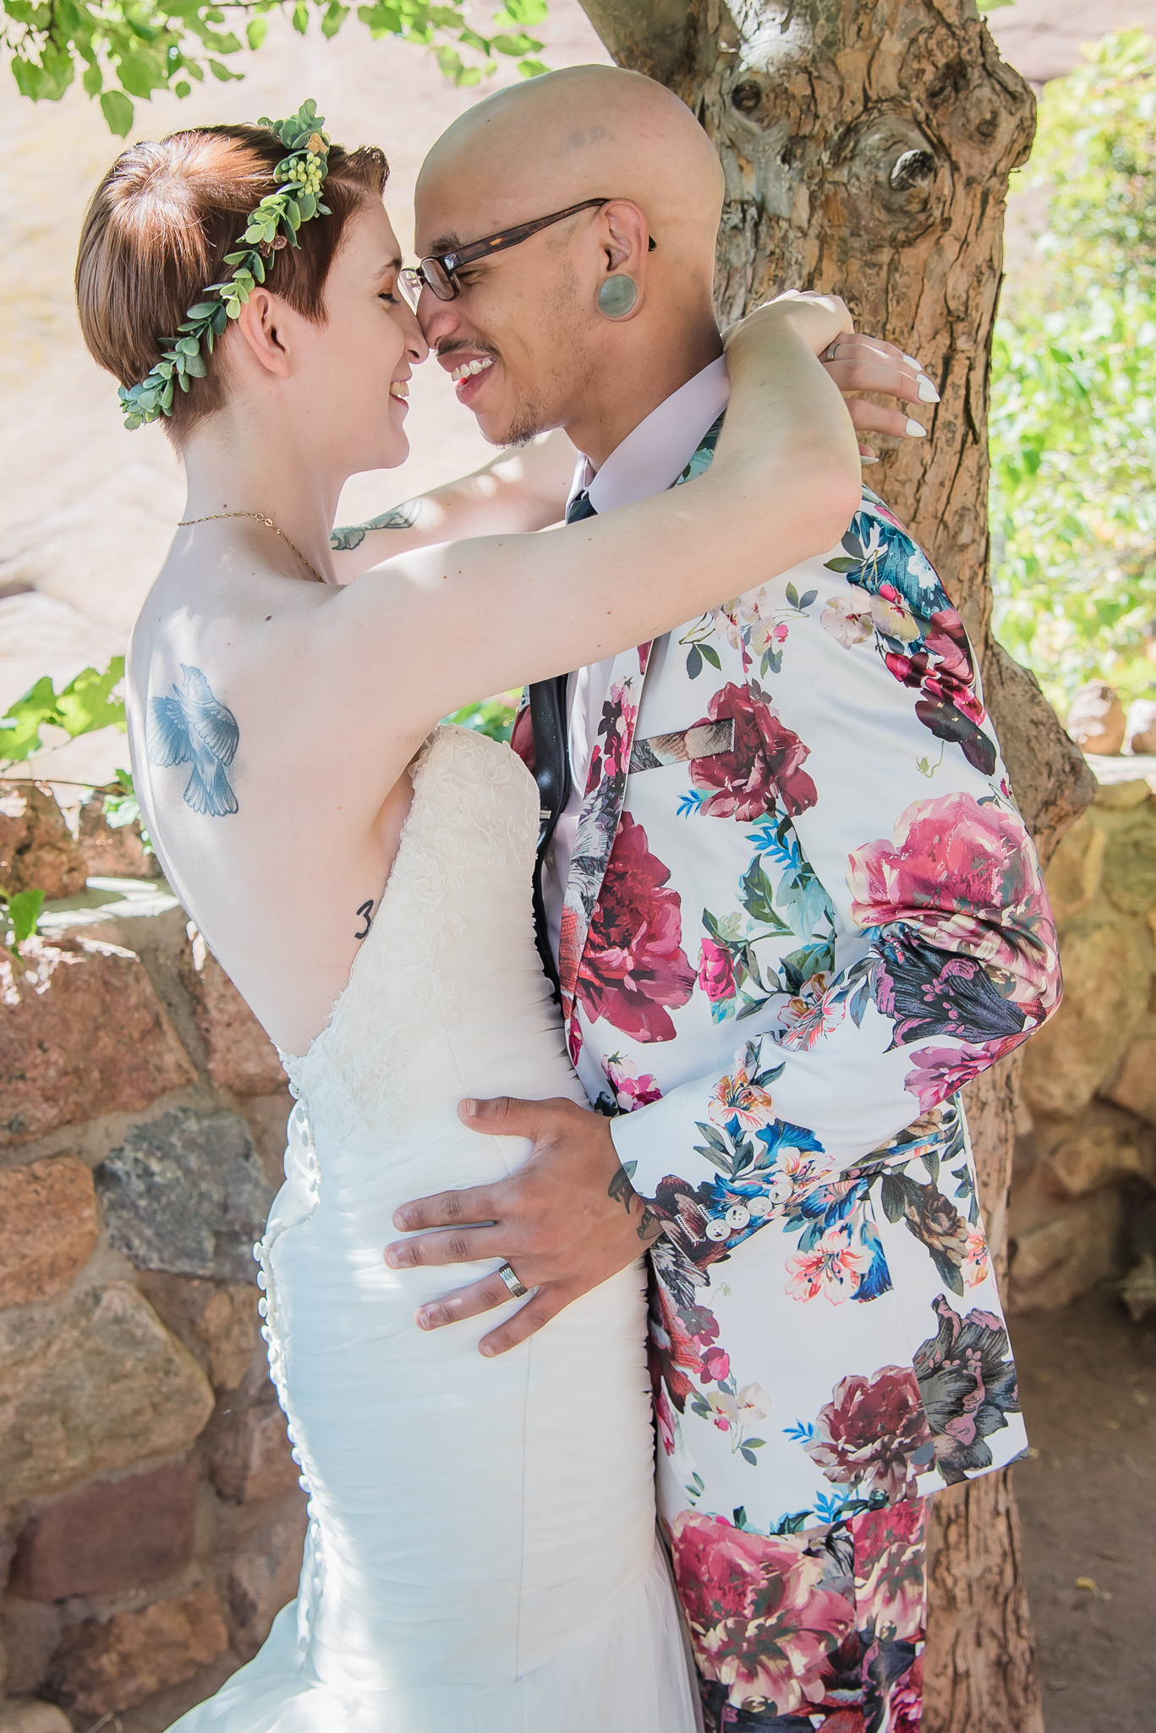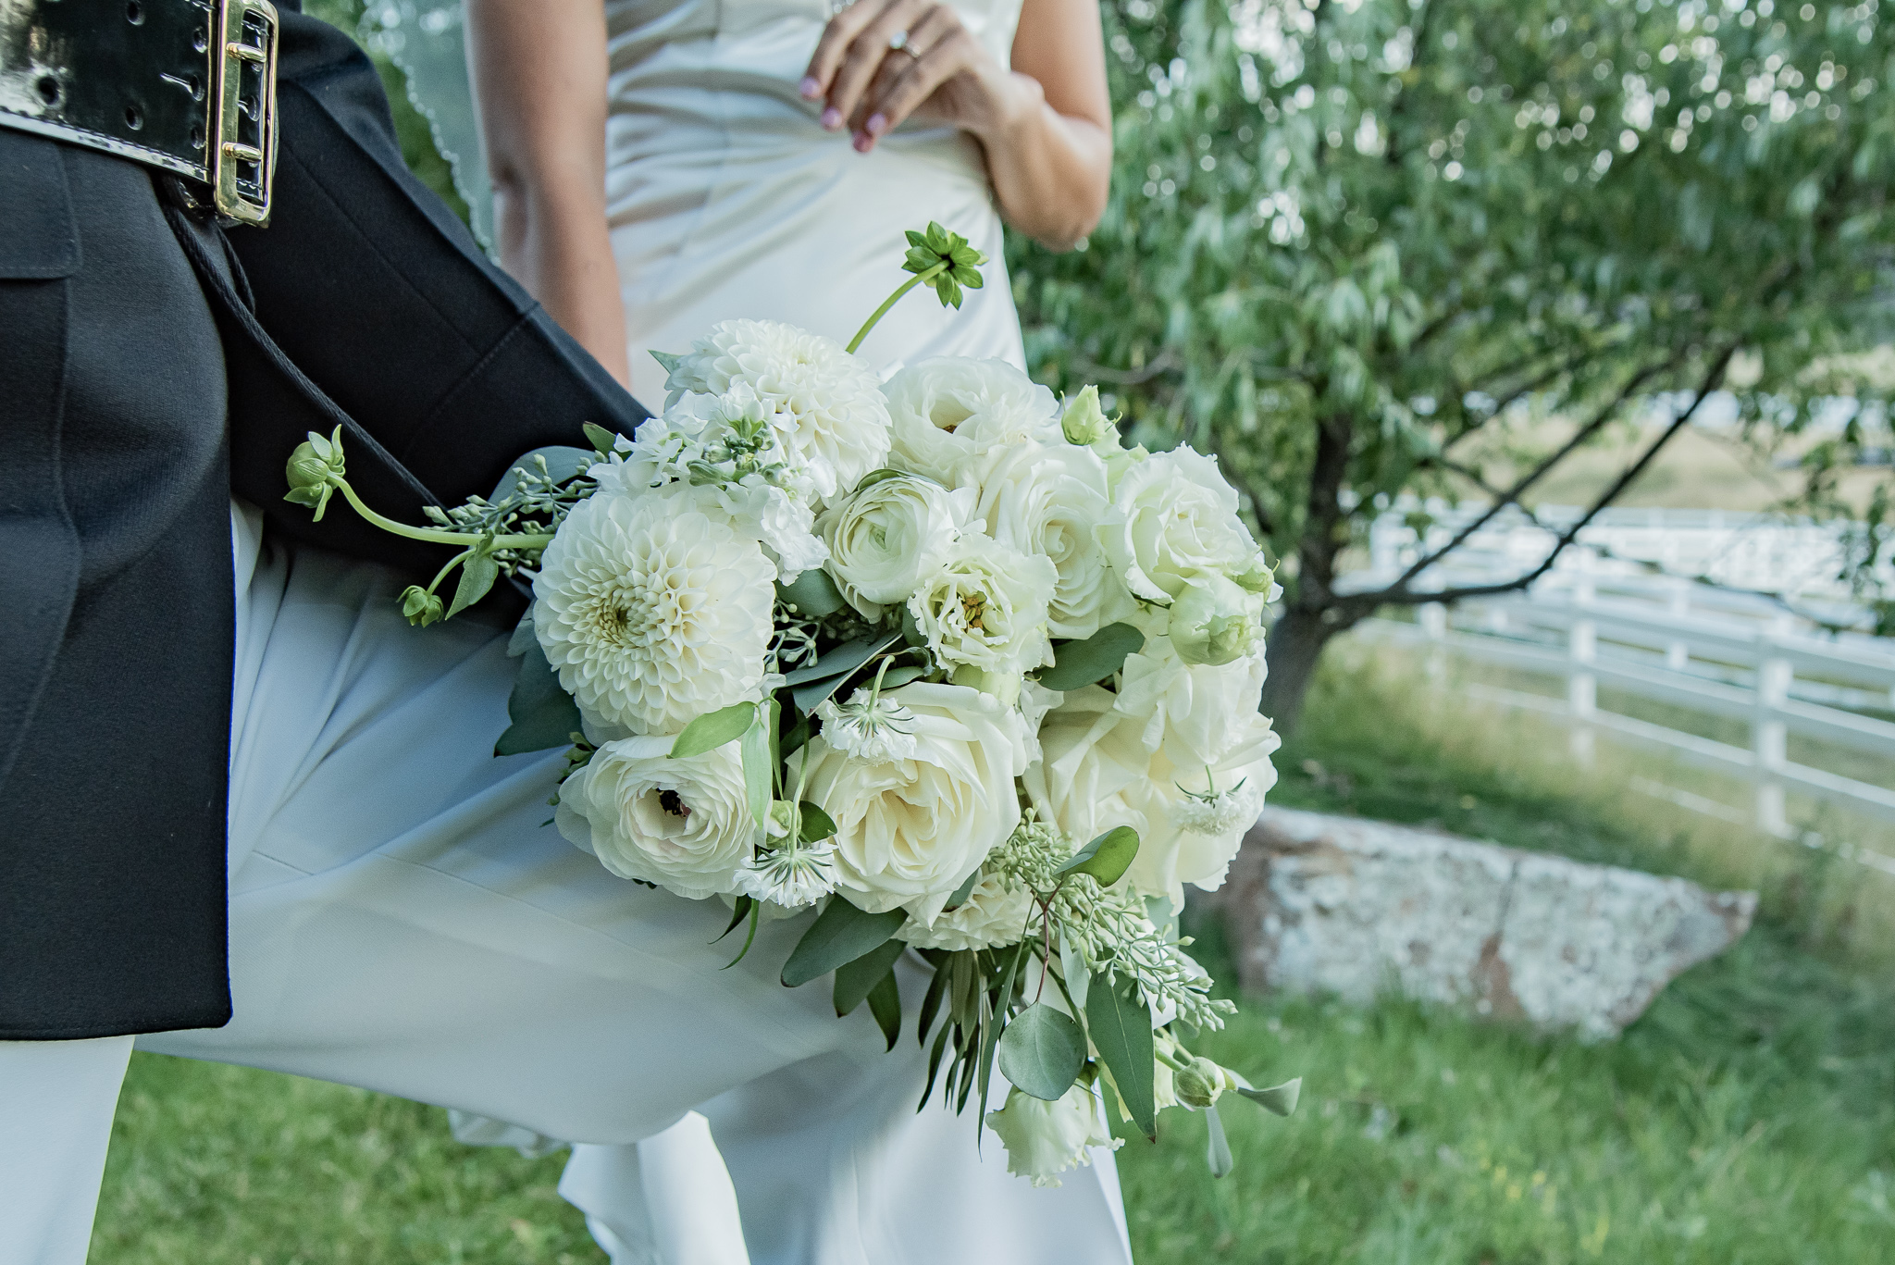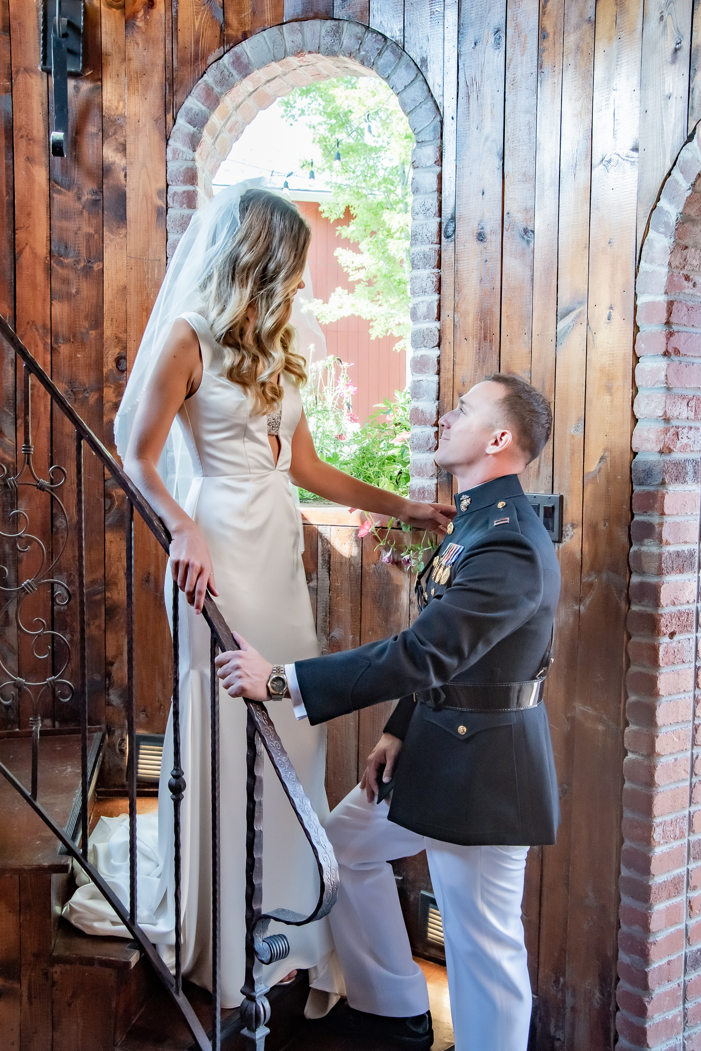

Included in package:

8 hours of photography with TWO photographers

Travel to your location of choice*

All coordination of details, paperwork, communication – prior, during and after the event

All edited photos provided to you via Dropbox online for immediate download to print/share/etc.

$50 off - 60 minute engagement photo session

$50 off each additional hour beyond the contracted 8 hours (must be included in the contract and planned prior to wedding day)

25% off Photo Booth rental

$5/hour donation to Robbie’s Hope suicide prevention organization in your name

Wedding Photo Package Standard

$2400.00

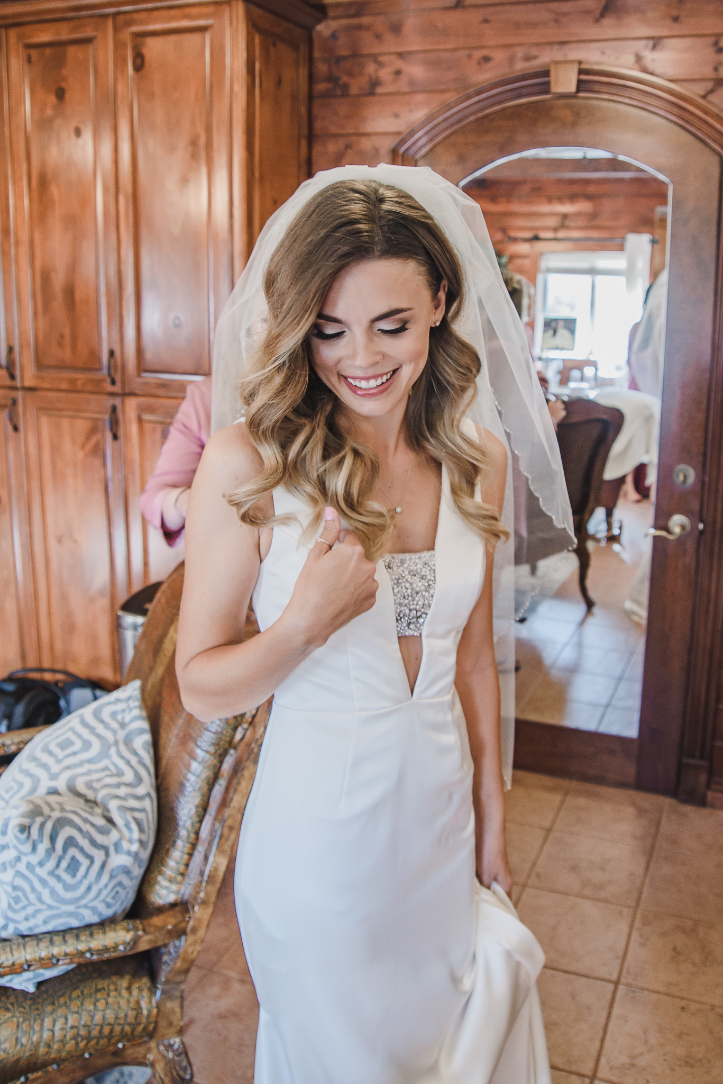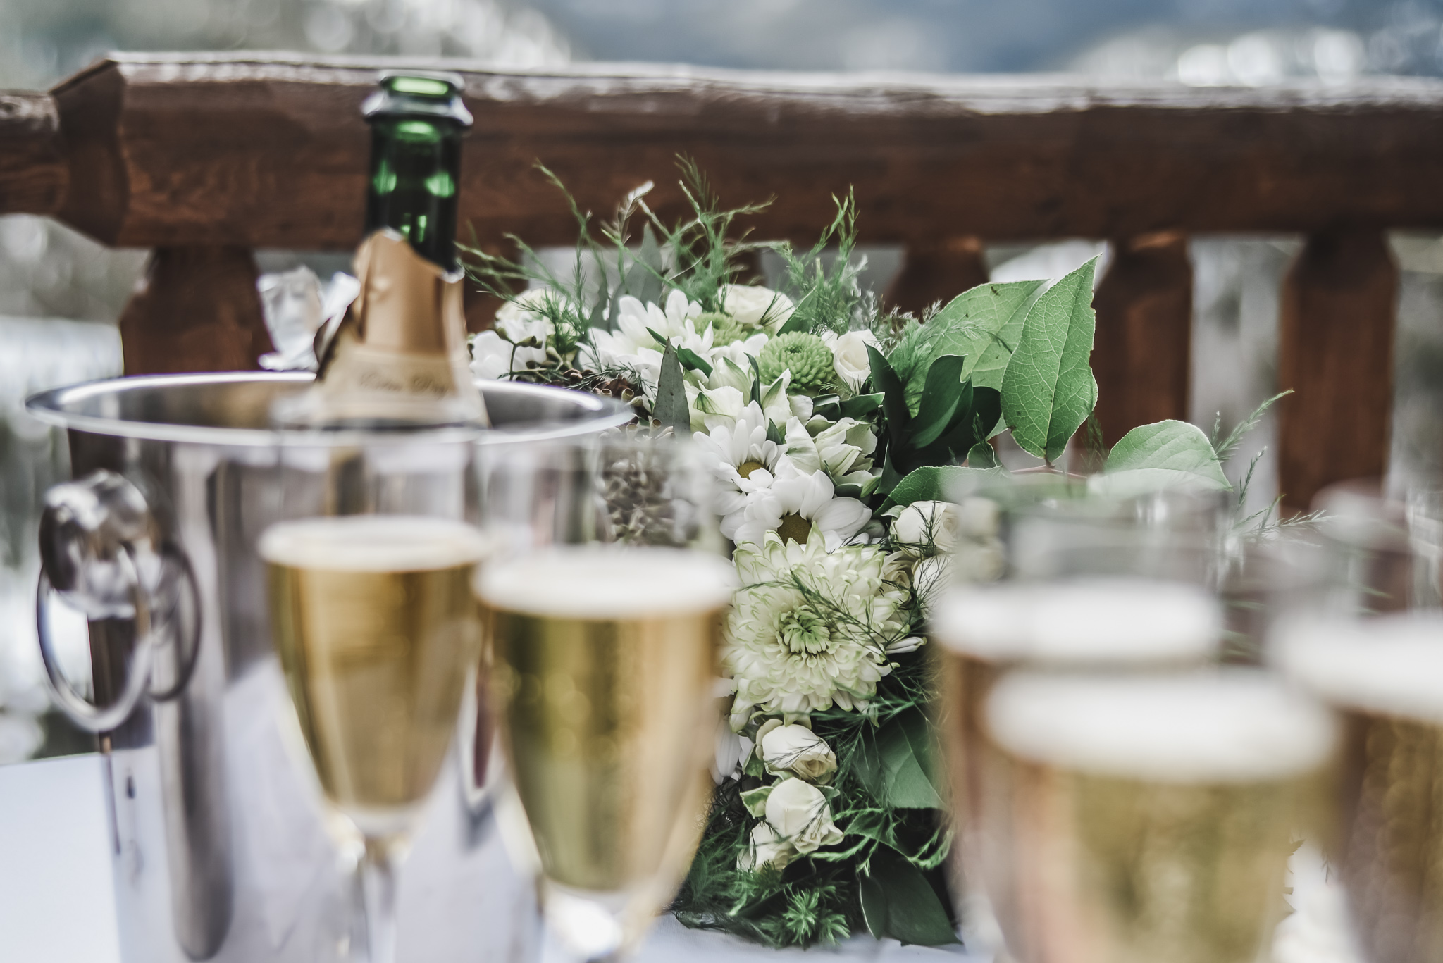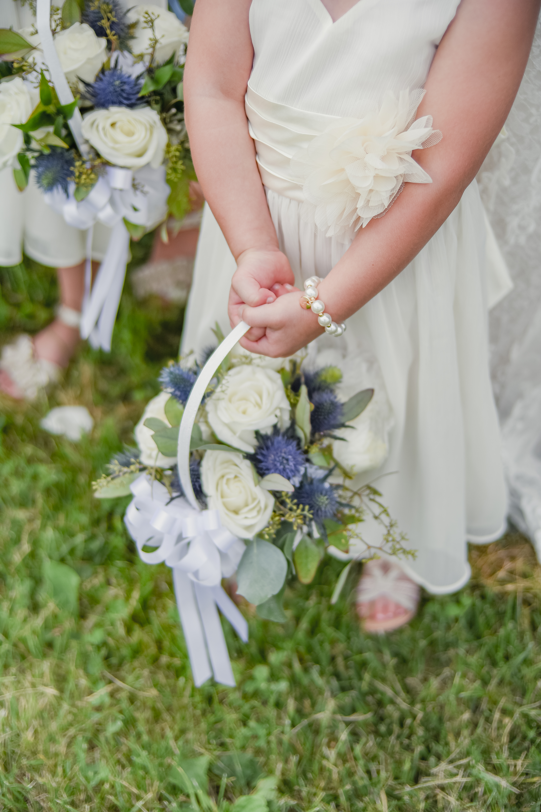

Included in package:

8 hours of photography with ONE photographer

Travel to your location of choice*

All coordination of details, paperwork, communication – prior, during and after the event

All edited photos provided to you via Dropbox online for immediate download to print/share/etc.

$25 off - 60 minute engagement photo session

$25 off each additional hour beyond the contracted 8 hours (must be included in the contract and planned prior to wedding day)

15% off Photo Booth rental

$5/hour donation to Robbie’s Hope suicide prevention organization in your name

Wedding Photo “Ala Carte” Packages

Package #1: $400/hour*

Included in package:

4+ hours of photography with TWO photographers

Travel to your location of choice**

All coordination of details, paperwork, communication – prior, during and after the event

All edited photos provided to you via Dropbox online for immediate download to print/share/etc.

$5/hour donation to Robbie’s Hope suicide prevention organization in your name

*Minimum of 4 hours

Package #2: $300/hour*

Included in package:

4+ hours of photography with TWO photographers

Travel to your location of choice**

All coordination of details, paperwork, communication – prior, during and after the event

All edited photos provided to you via Dropbox online for immediate download to print/share/etc.

$5/hour donation to Robbie’s Hope suicide prevention organization in your name

*Minimum of 4 hours

Wedding Videography

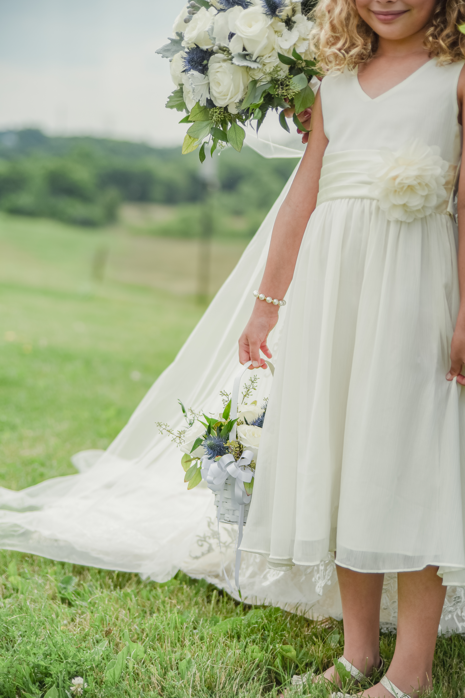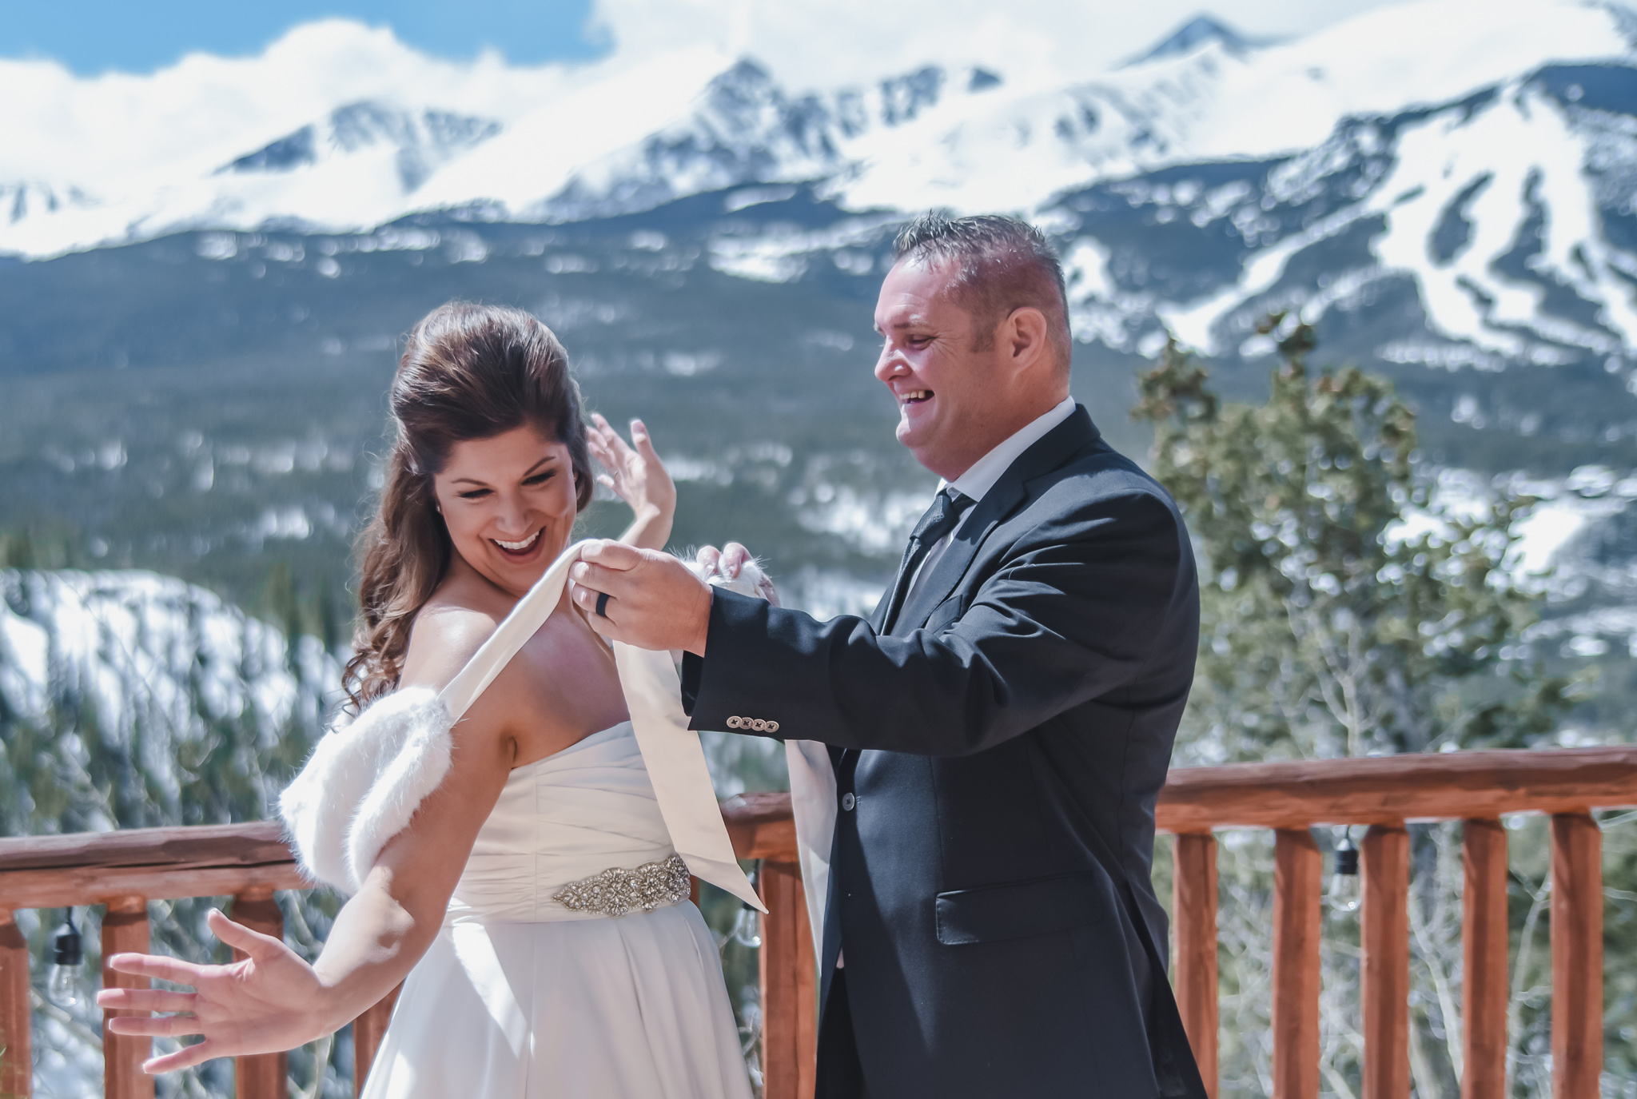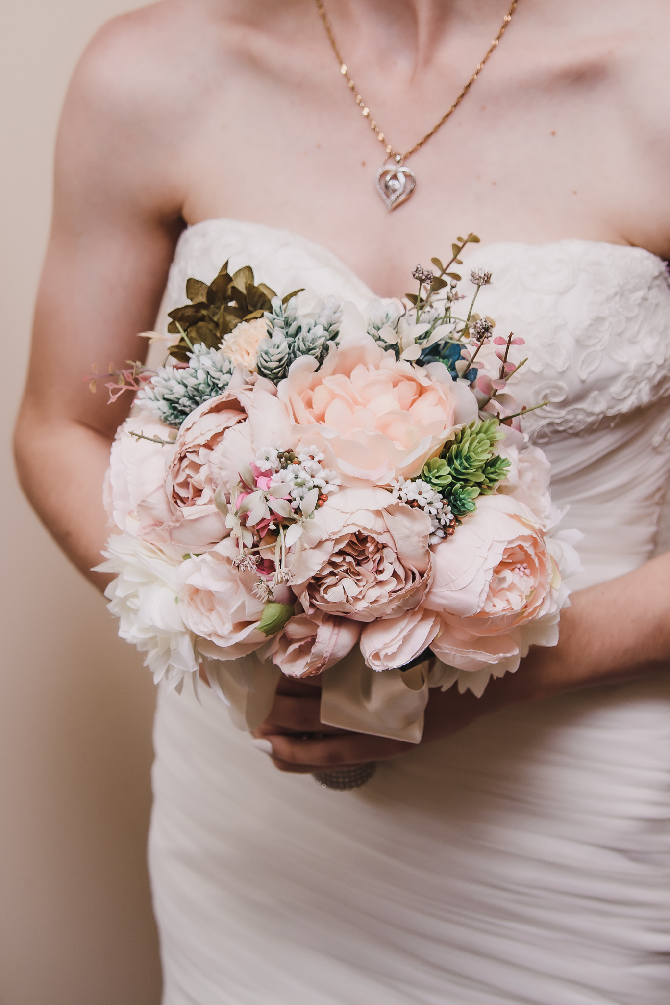

$300/hour*

Included in package:

4+ hours of videography with one videographer

Travel to your location of choice**

All coordination of details, paperwork, communication – prior, during and after the event

Professionally edited video provided to you via Dropbox online for immediate download to print/share/etc.

$5/hour donation to Robbie’s Hope suicide prevention organization in your name

*Minimum of 4 hours

Wedding Photo Booth

$500.00/total*

Included in package:

2 hours of photography

Professional equipment provided including – lighting, backdrops, camera, printer for immediate prints, etc.

All set up and take down at event

All props included – hats, fun glasses, wigs, etc.

Photo paper and supplies

* $500 fully refundable deposit required prior to event

**Travel fees of $25-$250 will be assessed on any location beyond 30 miles past Denver, CO 80238

